**To download:**

**Step-1: open the VScode and go to the terminal**

**Step-2: run ‘npm install react-bootstrap bootstrap’**

**Step-3: place ‘import ‘bootstrap/dist/css/bootstrap.min.css’ ’ in ‘index.js’ file in ‘src’ folder**

**To use its component:**

**Place in your file where you ant use it 🡪 ‘import {component} from react-bootstrap’, e.g.,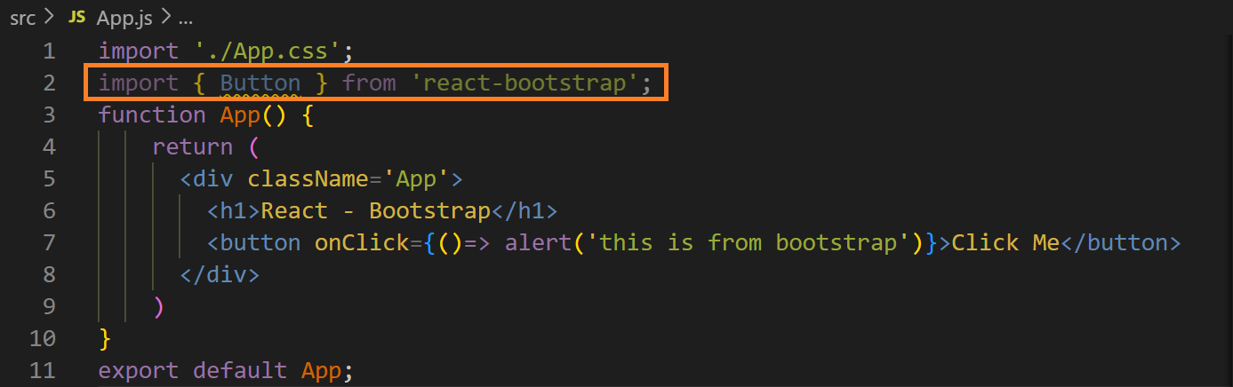output ↓**